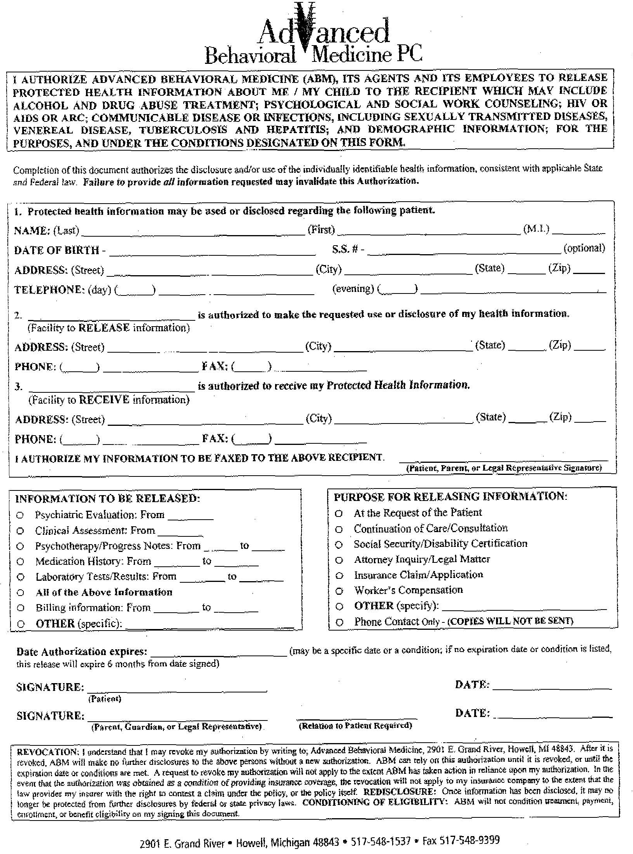
John Angle Jessen
03/08/1949
XXX-XX-5797
308 East Livingston Rd
Highland
MI
48357
Advanced Behavioral Medicine Dr. Marla Hires
2901 East Grand River Dr. Marla Hires
Howell
MI
48843
(517) 548-1537 (517) 548-9399
Axiom Requisition Copy Service
447 North Canal Road
Lansing
MI
48917
(877) 886-5090 (517) 886-4116
X
X
Order No.: 01-21912-001

